Report THEE - research practical Julia Eggenschwiler and Jaelle Häfliger

A computational model for antibiotic resistance

Abstract

Introduction
In today’s world the problem of antibiotic resistance in bacteria is as important as ever. Antibiotics, which proved to be an efficient solution against bacterial infections for approximately 90 years of use, might be soon ineffective against multiresistent bacteria. (MacGowan und Macnaughton 2017) Additionally, recent medical advancements, especially regarding various surgical procedures and immunosuppressive treatments strongly depend on antibiotics. (MacGowan und Macnaughton 2017) Therefore, this problem could have devastating effects on multiple levels. Recognizing the importance of this concern, we present a model for antibiotic resistance. Despite its limitations, it could help to understand the population dynamics of antibiotic resistance. In the model the application of antibiotic leads to a rapid decline of the bacterial population. The bacteria either have a strong or weak deleterious mutation, which could mutate to beneficial ones. Thus, the bacteria are either weakly or strongly sensitive to the antibiotic but are able to mutate respectively to a weak or strong antibiotic resistance. Backmutations are also considered in the model. We used it to predict which mutation would lead to more evolutionary rescue of the population. Also, the frequencies of the four mutants were documented. Therefore, the model helps to predict under which circumstances the different resistance mutations will be able to persist in the population and rescue it. Our expectation, namely that the strongly mutated organisms wouldn´t survive because the costs of their trade off are too high, was not confirmed. We thought the survival of the population would depend on the weakly mutated and strongly beneficial organisms. This prediction was also proven wrong. Both beneficial mutations could lead to the rescue of the population.

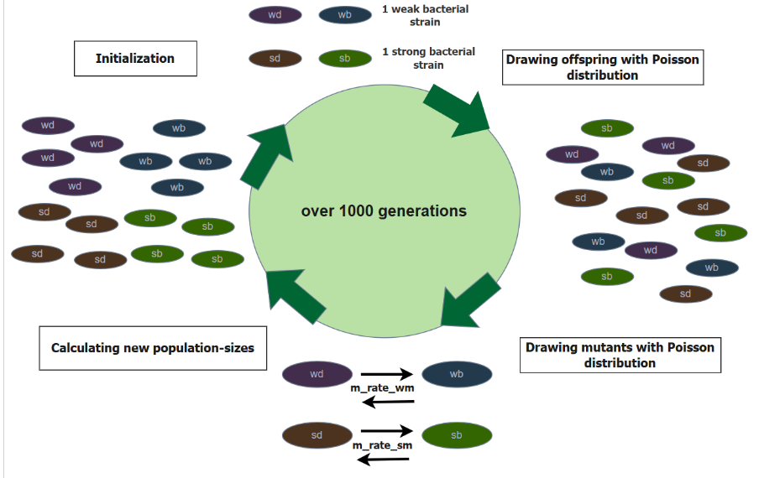
Methods

Figure 1: life cycle of the model, including the different steps the model goes through in one generation, created with draw.io

In figure 1, the life cycle of our model is visualized, showing one generation. At the initialization point of the model, there are four bacterial strains, indicated with the following abbreviations: “wd” = weak deleterious, “wb” =weak beneficial, “sd” =strong deleterious, “sb” =strong beneficial. In the first step, we draw offspring, using a Poisson distribution. In the second step we draw mutants, as well with a Poisson distribution. In both strains, the deleterious individuals can mutate to beneficial ones, and in the other direction (backmutation). The mutation rate of the weak strain is called m_rate_wm (“wd” to “wb” and “wb” to “wd”) and the mutation rate of the strong strain is called m_rate_sm (“sd” to “sb” and “sb” to “sd”). In the last step we calculate the new population sizes of the four mutants. For this calculation we use the following code in RStudio:
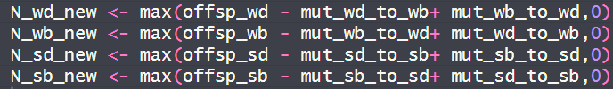
Figure 2: code-lines showing the calculation of the population-size of each mutant, in the function: “simulate_one_gen”, taken from the R-Markdown-file: “Evolutionary rescue_discrete time_Jaelle_Julia.Rmd”
The final simulation is then run until 1000 generation (parameter “max_gen” in the code).

Parameter/Variable | Description | Manipulation
init_wd, init_wb, init_sd, init_sb | initial population sizes of the 4 mutants | Fixed at 30 for the deleterious mutations  Set to 0 for the beneficial mutations
decay_rate_wm | decay rate of the weak mutation | Fixed to 0.05
decay_rate_sm | decay rate of the strong mutation | Fixed to 0.1
s_wm | selection-coefficient of weak mutation | Varied (0.1, 0.15, 0.20)
s_sm | selection-coefficient of strong mutation | Varied (0.25, 0.30, 0.35)
m_rate_wm | mutation rate of the weak mutation | Varied (4e-5, 5e-4, 6e-3)
m_rate_sm | mutation rate of the strong mutation | Varied (7e-5, 8e-4, 9e-3)
rescue_prob | rescue-probabilities of the 4 mutants | calculated
N_end_wd, N_end_wb, N_end_sd, N_end_sb | final population-size of the 4 mutants | calculated
max_gen | number of generations after which to stop the simulation | Fixed to 1’000
Figure 3: table of all parameters and variables used in the model, including a brief description and whether or not they were varied in the simulation

Figure 2 shows all parameters and variables which were used in this model. They rest upon the provided base model. Important deviations are that in our model we used four different initial population sizes (one for each mutant). In our simulations, we varied the values for the initial population sizes, but always set them all at the same value, this will also be explained in the Results section. We use two different decay rates, one for the weak bacterial strain and one for the strong strain. The decay rates are fixed in our model. We have two different parameters for selection coefficients and for mutation rates as well, one parameter for the weak strain and one for the strong strain. We generated plots, in which the two are fixed and in other plots we show the influence of the selection coefficient and/or mutation rate and therefore vary them. This will be indicated in the descriptions of the plots. To answer our question, we calculate the rescue probability. Another deviation from the base-model is that we calculate the end population size (after 1000 generations) for all four mutants.
To create and run the simulation we used RStudio version 4.4.1. To run the code, it is required that the R-packages “dplyr”, “ggplot2” and “tidyr” and installed and loaded.

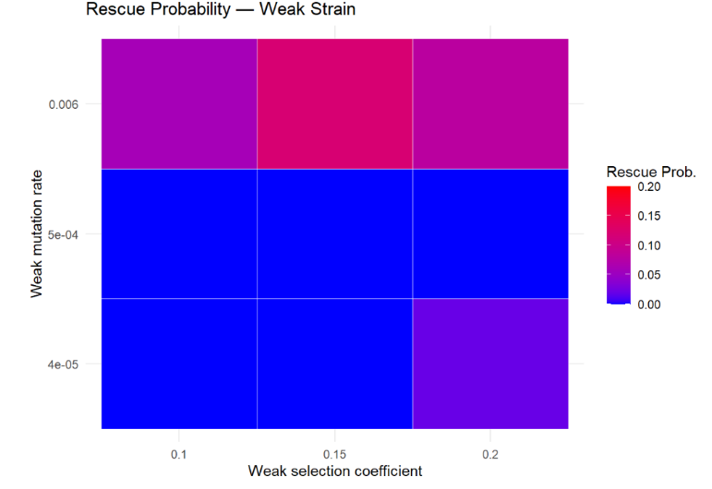
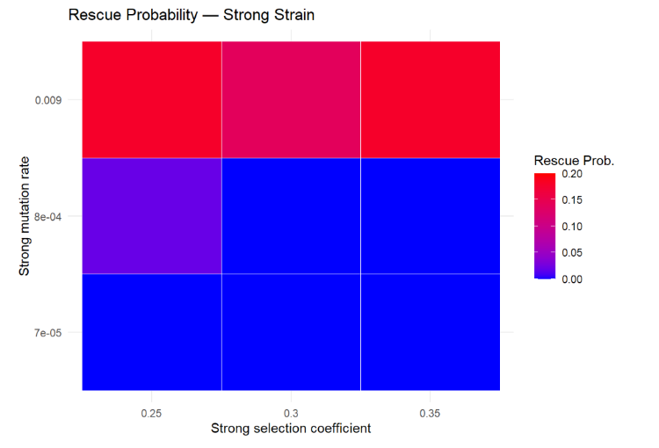
Results
Figure 5:
Figure 4:

Figures 4 and 5: Heatmaps showing the probability of rescue for the two bacterial strains separately (weak strain, strong strain). The x-axis shows the varied selection coefficients for the weak strain (Figure 4) and for the strong strain (Figure 5). The y-axis shows the varied mutation rates for the weak strain (Figure 4) and the strong strain (Figure 5). The colour-bar indicates the rescue probability. The bar goes from blue = rescue probability of zero to red = rescue probability of 0.2.
Parameters used for this plot:
init_wd <- 30, init_wb <- 0, init_sd <- 30, init_sb <- 0. decay_rate_wm <- 0.05. decay_rate_sm <- 0.1, max_gen <- 1000, no_replicates <- 50
s_values_wm <- c(0.10, 0.15, 0.20)
s_values_sm <- c(0.25, 0.30, 0.35)
m_values_wm <- c(4e-5, 5e-4, 6e-3)
m_values_sm <- c(7e-5, 8e-4, 9e-3)

Figures 4 and 5 above show Heatmaps, in which we combined different selection coefficients on the x-axis, different mutation rates on the y-axis, and the rescue-probability, indicated by the colour. Figure 12 shows the rescue probability of the strong deleterious mutation. In this case, rescue is very low. The highest rescue probability is reached, with the combination of the highest selection coefficient of 0.35 and the highest mutation rate of 0.009. In this case the probability of rescue is about 0.20. The lowest rescue probability is reached with the weakest selection coefficient of 0.25 and an intermediate mutation rate of 0.008. Overall, this mutation created the lowest probability of rescue.
Figure 13 shows the strong beneficial mutation. For this mutation, rescue is overall really high, but there are some differences visible between the varied selection coefficients and mutation rates. With the highest mutation rate of 0.35 and the highest mutation rate of 0.009, the population reaches a probability of rescue of almost 1. The lowest rescue probability in this case lies around 0.30. It is reached with the lowest selection coefficient of 0.25 and both the lowest mutation rate of 0.007 and the highest mutation rate of 0.009. In this case, it is visible that the lowest selection coefficient resulted in the lowest rescue probability and with increasing selection coefficient, the recue probability increased as well.

Figure 14 shows the weak deleterious mutation. For this mutation big differences are noticeable. With the lowest selection coefficient, rescue is essentially zero, almost independent of the mutation rates. Only for the lowest mutation rate of 0.004, rescue is slightly higher than zero. Gradual shifts are noticeable, with increasing selection coefficient, rescue increases strongly. With an intermediate selection coefficient of 0.15, rescue of about 0.20 is reached. Only with the lowest mutation rate of 0.004 is rescue at approximately 0.1 and therefore lower. With the highest selection coefficient of 0.20 rescue probability is close to 1, for all three mutation rates, even though the mutation has deleterious effects.

Finally, figure 15 shows the weak beneficial mutation. The pattern is quite similar to the weak deleterious mutation. It is noticeable however, that with the intermediate selection coefficient of 0.15, the rescue probability is higher compared to the weak deleterious mutation (figure 14). It reaches for low and intermediate mutation rate a probability of about 0.50 and for the highest mutation rate of 0.006 a rescue probability of approximately 0.60.

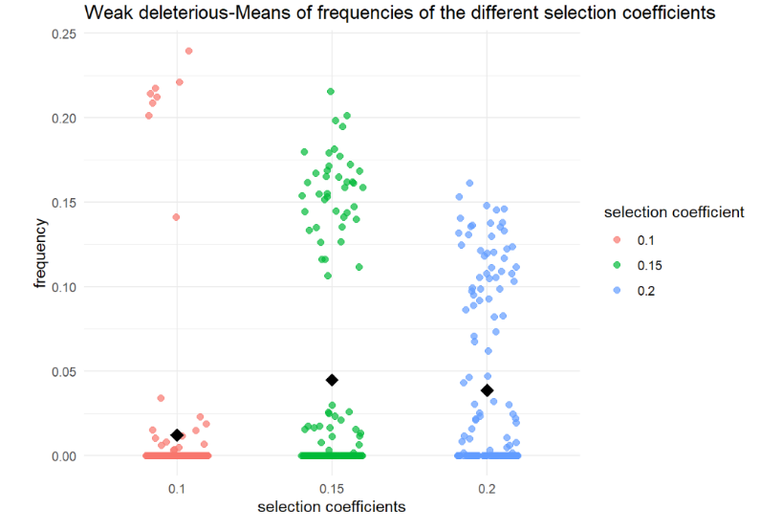
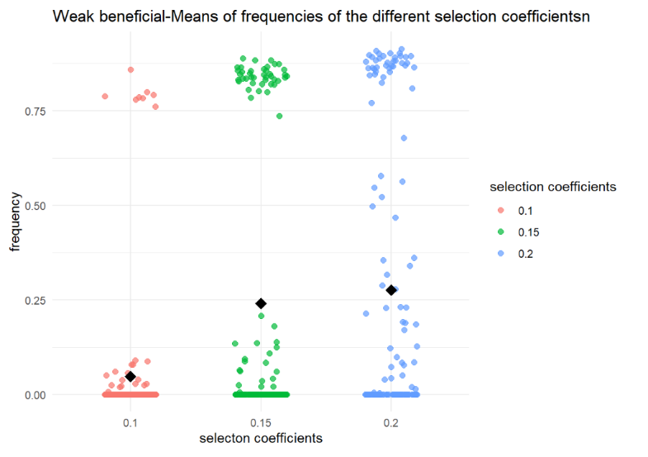
Figure 7:
Figure 6:

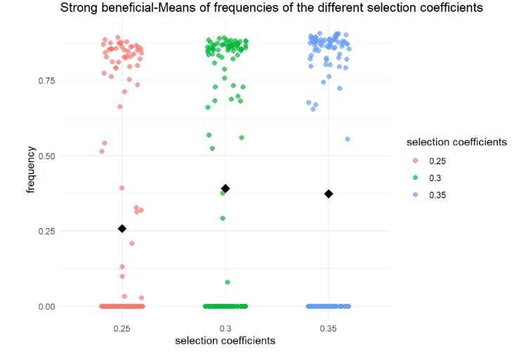
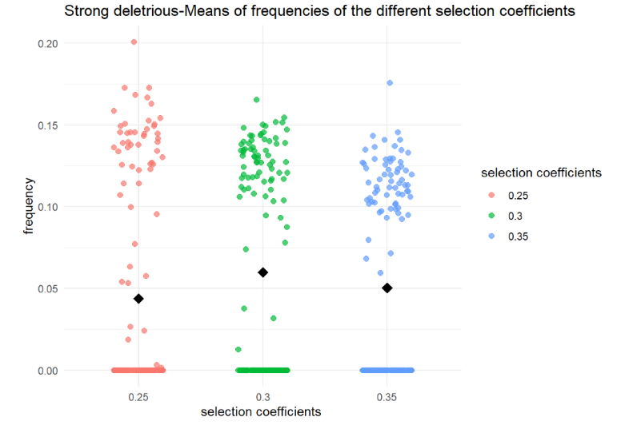
Figure 9:
Figure 8:

Figures 6-9: Scatterplots showing the frequency of each mutant separately dependent on different selection coefficients. The x-axes shows three different selection-coefficients and the y-axes shows the frequency. For figure 6 and 7 (weak deleterious and weak beneficial three weak selection coefficients were used. For figure 8 and 9 (strong deleterious and strong beneficial) three strong selection coefficients were used.
Parameters used for these plots:
init_wd <- 30, init_wb <- 0, init_sd <- 30, init_sb <- 0, m_rate_wm <- 0.05, m_rate_sm <- 0.07, decay_rate_wm <- 0.05, decay_rate_sm <- 0.1, max_gen <- 1000, no_replicates <- 50, s_values_wm <- c(0.10,0.15,0.2), s_values_sm <- c(0.25,0.30,0.35)

In the figures 6-9 above, we plotted the frequency of each mutant separately with different selection coefficients. For the weak deleterious and weak beneficial mutation (Figure 4 and 5) we used the selection coefficients 0.1, 0.15 and 0.20. The purpose of these plots is mainly to show the effect of each mutation on a population and how the frequencies differ. Another aspect is to show the stochasticity of our model, using scatterplots, where every point represents one of a total of 50 replicates that were simulated. Since the model includes a weak strain and strong strain, we chose 3 selection-coefficients for each of them. Figure 4 shows the plot of the weak deleterious strain. Frequencies are very low, going from a mean of almost 0.0000 for the lowest s of 0.1 to 0.0010 with an s of 0.15 to approximately 0.0020 with the highest s of the weak mutation with the value 0.20.
Figure 5 shows the frequency of the weak beneficial mutation. With increasing value of the selection coefficients, the frequency increases. With highest selection coefficient of 0.20, the mutation reaches a frequency of about 0.55. There are big differences, since with the lowest selection coefficient of 0.10 the mean frequency is only about 0.05, with many cases in which the frequency is 0.00. To visualize the results better, the y-axes show different scales, so that small changes in mutations with low frequencies can be analysed as well.
For the strong deleterious and strong beneficial mutation (Figure 6 and 7) we used the selection coefficients 0.25, 0.30 and 0.35. Figure 6 shows the frequency of the strong deleterious mutation. Variation is significant in this mutation. The lowest s of 0.25 results in a mean frequency of about 0.0030. The s 0.30 and 0.35 are very similar, resulting in a frequency of approximately 0.0040.
Figure 7 shows the frequency of the strong beneficial mutation. With increasing s, the mean frequency of the mutation increases. With the lowest s of 0.25 variation is large, the frequency can reach from 0 to 1, resulting in a mean of about 0.50. The intermediate s of 0.30 shows a mean frequency of 0.75, with slightly less variation. The s of 0.35 results in the highest frequencies, with a mean of approximately 0.88 and the smallest amount of variation.

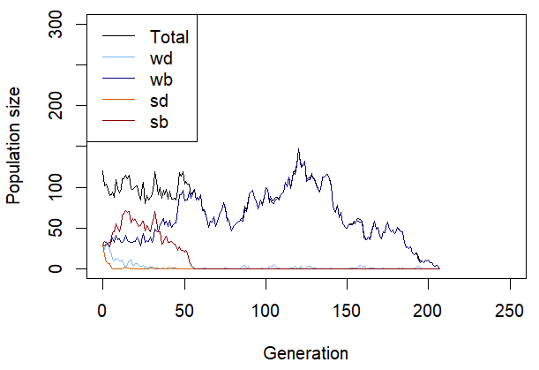
Figure 10: Displays the development of one population and how the frequencies of the mutants change. On the x-axis is the generation with a maximum of 250, while the y-axis represents the population size with a maximum of 300. The initial number of individuals for each mutant is 30.
Parameters used for the plot:
init_wd <- 30, init_wb <- 30, init_sd <- 30, init_sb <- 30, m_rate_wm <- 0.003, m_rate_sm <- 0.005, decay_rate_wm <- 0.1, decay_rate_sm <- 0.2, max_gen <- 1000, s_wm <- 0.1, s_sm <- 0.2

Figure 10 shows the most common outcome of simulating one population where the initial number of bacteria for each mutant is 30. Most of the time the weak beneficial mutants take over the population. Nevertheless, the population mostly dies within approximately 250 populations. Sometimes the weak deleterious and rarely also the strong beneficial mutants are able to thrive longer than 250 generations. These graphs can be seen in the additional information. Furthermore, the fate of the weak and strong deleterious bacteria is always extinction.
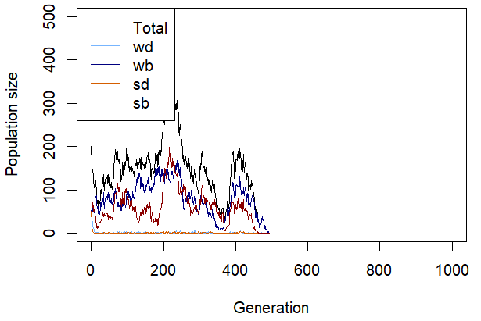
Figure 11: Displays the development of one population and how the frequencies of the mutants change. On the x-axis is the generation until 1000, while the y-axis represents the population size until 500. The initial number of individuals for each mutant is 50.
Parameters used for the plot:
init_wd <- 50, init_wb <- 50, init_sd <- 50, init_sb <- 50, m_rate_wm <- 0.002, m_rate_sm <- 0.003, decay_rate_wm <- 0.1, decay_rate_sm <- 0.2, max_gen <- 1000, s_wm <- 0.1, s_sm <- 0.2

Moving on to Figure 11, which is the same graph as Figure 8, only that the initial number of each mutant is now 50 and the mutation rates were adjusted. The population still faces extinction most of the time but over a longer time scale. They rarely persist past 1000 generations. Examples of this long persistence can again be observed in the additional information at the bottom. Also important to note is that the populations consisting of weak beneficial mutations get past the 1000th generation more often than the strong beneficial mutants. However overall, they can survive often longer than 250 generations in contrast to the simulation in Figure 8. To highlight this difference we chose different x-and y-axis maximums.

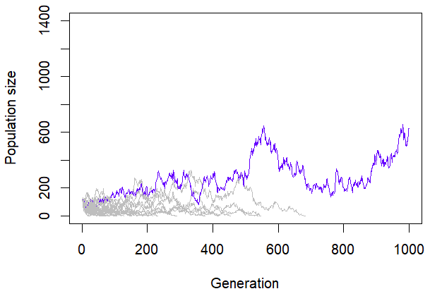
Figure 12: Shows the outcome of 30 populations, each line represents one population. One the x-axis is the generation with the maximum of 1000 and on the y-axis is the population size displayed, with the maximum of 1400. The initial number of individuals for each mutant is 30. The grey lines indicate that this population went extinct before the 1000th generation.
Parameter used for this plot:
init_wd <- 30, init_wb <- 30, init_sd <- 30, init_sb <- 30, m_rate_wm <- 0.003, m_rate_sm <- 0.005, decay_rate_wm <- 0.1, decay_rate_sm <- 0.2, max_gen <- 1000, no_replicates <- 30, s_wm <- 0.1, s_sm <- 0.2

In the Figure above each line stands for one independent population. There are 30 replicates respectively populations simulated at the same time in the graph. The initial number of bacteria per mutant is again 30, so an initial population size of 120. The only colourful line indicates that in this simulation just one population persists for more than 1000 generations, even though in a lot of simulations all populations die before they reach the 1000th generation (additional information).

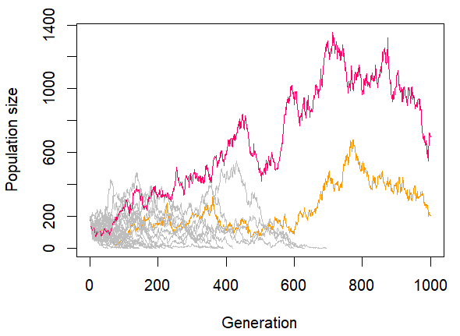
Figure 13: Shows the outcome of 30 populations, each line represents one population. One the x-axis is the generation with the maximum of 1000 and on the y-axis is the population size displayed, with the maximum of 1400. The initial number of individuals for each mutant is 50.
Parameter used for this plot:
init_wd <- 50, init_wb <- 50, init_sd <- 50, init_sb <- 50, m_rate_wm <- 0.002, m_rate_sm <- 0.003, decay_rate_wm <- 0.1, decay_rate_sm <- 0.2, max_gen <- 1000, no_replicates <- 30, s_wm <- 0.1, s_sm <- 0.2

Figure 13 displays again the same simulation as in Figure 10 just that the initial number per mutant changed to 50 and the mutation rates were adjusted. There are two colorful lines, indicating that two populations survived past the 1000th generation. There are also cases where just one or even three populations persisted, which can be observed in the additional material. This is a difference to the simulation before, where only sometimes one population is able to survive. However, in this simulation it still happens that all 30 populations go extinct earlier than a thousand generations even though less frequent. Also noticeable is that the model is pretty stochastic, meaning a lot of fluctuations are present.

Discussion (not done)

The outputs of Figures 8 and 9 suggest that the strong and weak deleterious mutants are both doomed to extinction. Even after running the simulation for multiple times, they always died out at the very beginning. We assume that they die too early before they are able to establish an equilibrium with the corresponding beneficial mutations. The beneficial mutations persist longer; however, it always ends in one beneficial mutation in taking over the population and the other one dying. This either leads to the survival of the population other the extinction of the mutant and therefore the mutation. Although there seem to be cases where the two mutants can coexist for a certain period. An example is in the additional information. We observed that the weak beneficial mutation is more capable of taking over the population and to rescue it more often. The reason seems to be that the trade-off of the weak mutants brings less costs. (search paper) The initial population size also may play a role in the rescue probability. With a bigger population size of 200 (50 per mutant) the population survives more often.
Regarding Figures 10 and 11, which simulate 30 populations each. The trend of populations being able to survive more frequently with a higher initial population size is also visible. In the graphs with the higher population size (50 for each mutant) more populations can persist (1-3) than in the smaller population size (1).

Important to note are the limitations of our model. We just defined one single value for the different selection coefficients, mutation rates and decay rates for most of the simulations. Furthermore, a bacterium naturally has more than one weak or strong mutation that selection acts on. Also, the horizontal gene transfer that some bacteria can do, is not included in our model. Another point is that the parameters of the model are not adjusted to fit the behaviour of the bacteria in a human body, which could be improved in another model. (or done?: search paper)

References
MacGowan, Alasdair; Macnaughton, Emily (2017): Antibiotic resistance. In: Medicine 45 (10), S. 622–628. DOI: 10.1016/j.mpmed.2017.07.006.

Author contributions

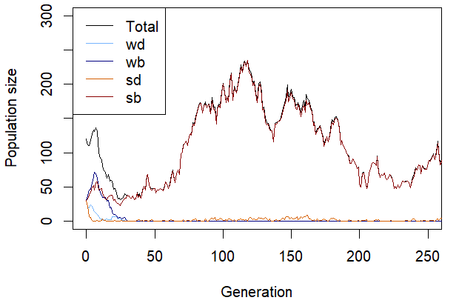
Additional Information
Figure 8.1: Displays the development of one population and how the frequencies of the mutants change. On the x-axis is the generation with a maximum of 250, while the y-axis represents the population size with a maximum of 300. The initial number of individuals for each mutant is 30. In this output the strong beneficial mutation takes over the population and rescues it.
Parameters used for the plot:
init_wd <- 30, init_wb <- 30, init_sd <- 30, init_sb <- 30, m_rate_wm <- 0.003, m_rate_sm <- 0.005, decay_rate_wm <- 0.1, decay_rate_sm <- 0.2, max_gen <- 1000, s_wm <- 0.1, s_sm <- 0.2

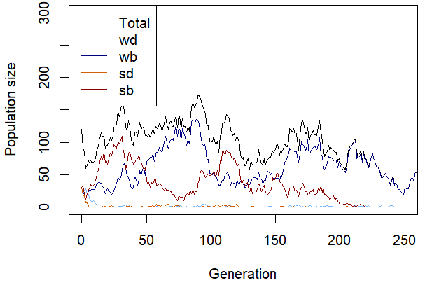
Figure 8.2: Displays the development of one population and how the frequencies of the mutants change. On the x-axis is the generation with a maximum of 250, while the y-axis represents the population size with a maximum of 300. The initial number of individuals for each mutant is 30. In this graph a period of coexistence can be observed until approximately the 200th generation.
Parameters used for the plot:
init_wd <- 30, init_wb <- 30, init_sd <- 30, init_sb <- 30, m_rate_wm <- 0.003, m_rate_sm <- 0.005, decay_rate_wm <- 0.1, decay_rate_sm <- 0.2, max_gen <- 1000, s_wm <- 0.1, s_sm <- 0.2

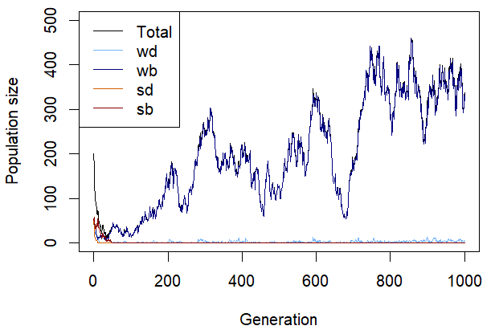
Figure 9.1: Displays the development of one population and how the frequencies of the mutants change. On the x-axis is the generation with a maximum of 1000, while the y-axis represents the population size with a maximum of 500. The initial number of individuals for each mutant is 50. The output shows evolutionary rescue through the weak beneficial mutant.
Parameters used for the plot:
init_wd <- 30, init_wb <- 30, init_sd <- 30, init_sb <- 30, m_rate_wm <- 0.003, m_rate_sm <- 0.005, decay_rate_wm <- 0.1, decay_rate_sm <- 0.2, max_gen <- 1000, s_wm <- 0.1, s_sm <- 0.2

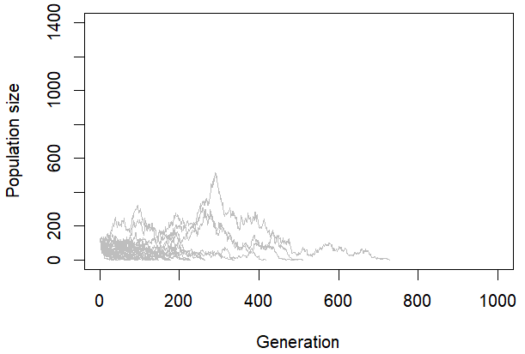
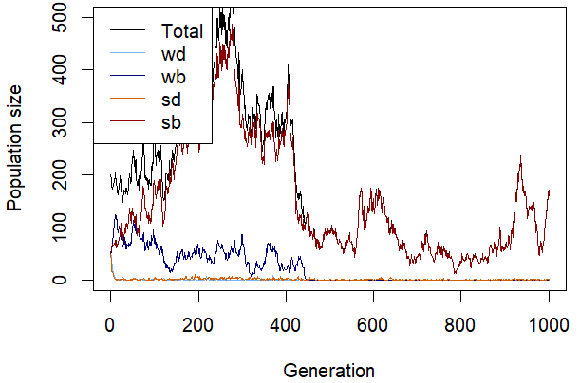
Figure 10.1: Shows the outcome of 30 populations, each line represents one population. One the x-axis is the generation with the maximum of 1000 and on the y-axis is the population size displayed, with the maximum of 1400. The initial number of individuals for each mutant is 30. The grey lines indicate that this population went extinct before the 1000th generation. In this case all populations went extinct before the 1000th generation.
Parameter used for this plot:
init_wd <- 30, init_wb <- 30, init_sd <- 30, init_sb <- 30, m_rate_wm <- 0.003, m_rate_sm <- 0.005, decay_rate_wm <- 0.1, decay_rate_sm <- 0.2, max_gen <- 1000, no_replicates <- 30, s_wm <- 0.1, s_sm <- 0.2
Figure 9.2: Displays the development of one population and how the frequencies of the mutants change. On the x-axis is the generation until 1000, while the y-axis represents the population size until 500. The initial number of individuals for each mutant is 50. The graph represents the take over of the strong beneficial mutants.
Parameters used for the plot:
init_wd <- 50, init_wb <- 50, init_sd <- 50, init_sb <- 50, m_rate_wm <- 0.002, m_rate_sm <- 0.003, decay_rate_wm <- 0.1, decay_rate_sm <- 0.2, max_gen <- 1000, s_wm <- 0.1, s_sm <- 0.2

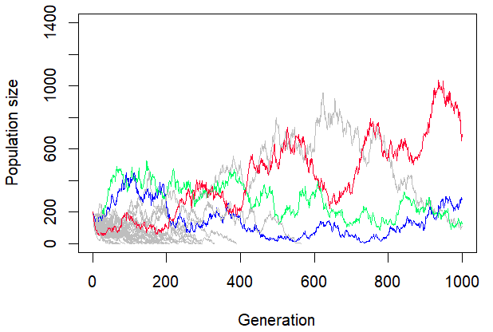
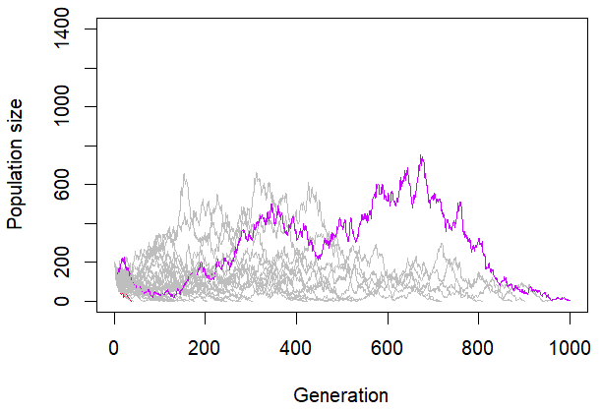
Figure 11: Shows the outcome of 30 populations, each line represents one population. One the x-axis is the generation with the maximum of 1000 and on the y-axis is the population size displayed, with the maximum of 1400. The initial number of individuals for each mutant is 50. In this graph three populations persist past a thousand generations.
Parameter used for this plot:
init_wd <- 50, init_wb <- 50, init_sd <- 50, init_sb <- 50, m_rate_wm <- 0.002, m_rate_sm <- 0.003, decay_rate_wm <- 0.1, decay_rate_sm <- 0.2, max_gen <- 1000, no_replicates <- 30, s_wm <- 0.1, s_sm <- 0.2
Figure 11: Shows the outcome of 30 populations, each line represents one population. One the x-axis is the generation with the maximum of 1000 and on the y-axis is the population size displayed, with the maximum of 1400. The initial number of individuals for each mutant is 50. In this graph only one population survives past a thousand generations.
Parameter used for this plot:
init_wd <- 50, init_wb <- 50, init_sd <- 50, init_sb <- 50, m_rate_wm <- 0.002, m_rate_sm <- 0.003, decay_rate_wm <- 0.1, decay_rate_sm <- 0.2, max_gen <- 1000, no_replicates <- 30, s_wm <- 0.1, s_sm <- 0.2

